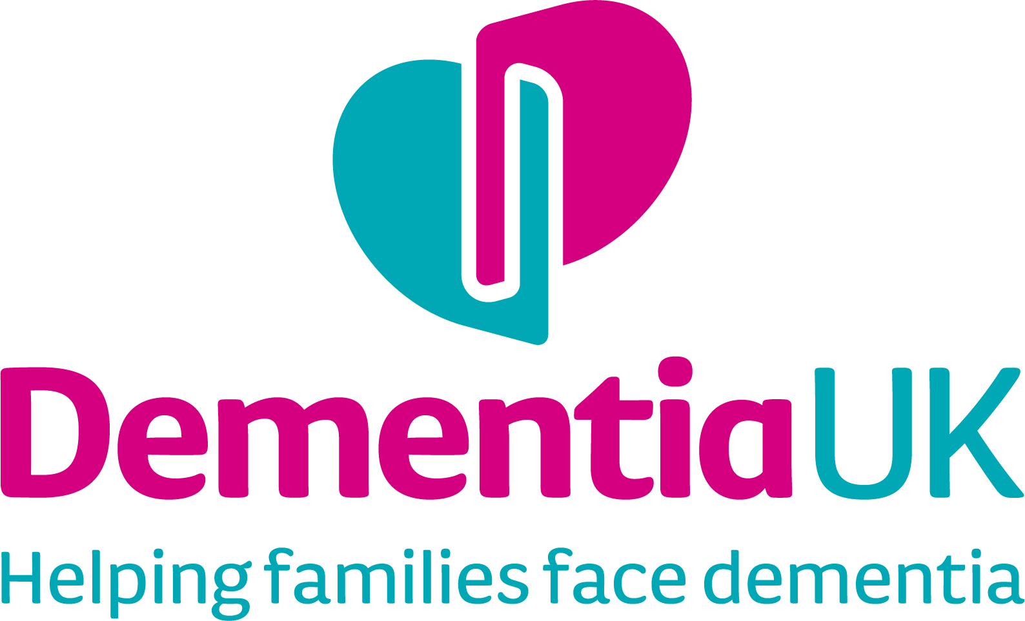
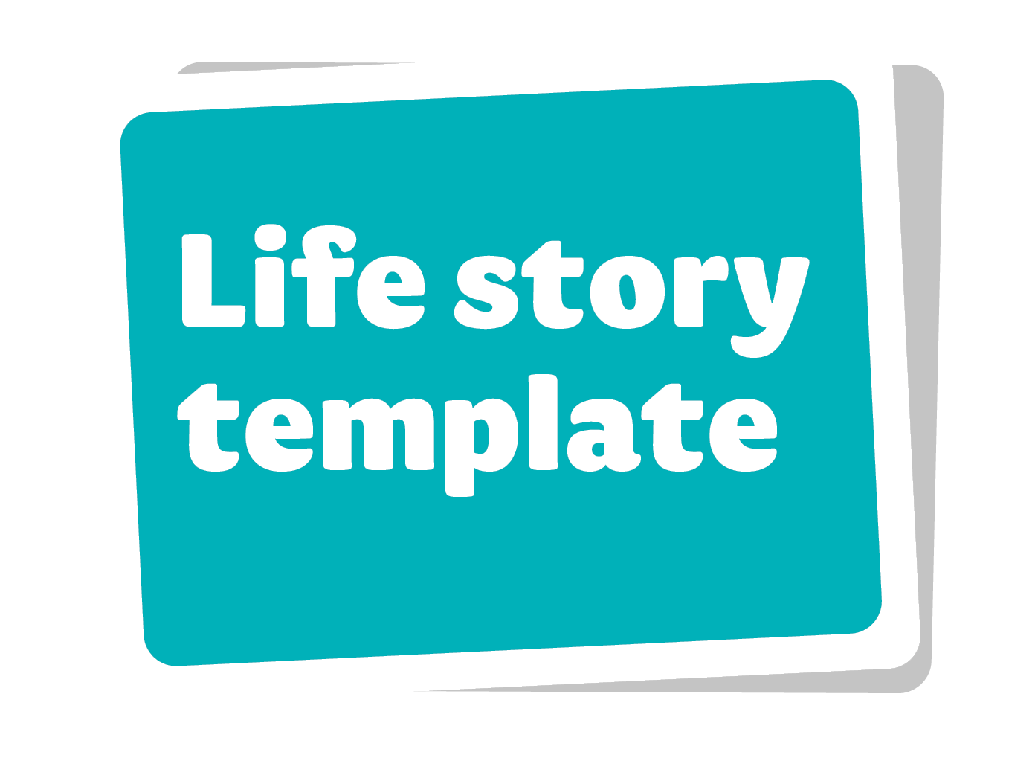

A life story is a record of someone’s personal information, past and present life, and future wishes. It can be shared with family members, friends and health and social care professionals so they understand more about the person and can provide the best possible care and support.
Ideally, you should compile a life story by working closely together with the person living with dementia. You may want to use our template alongside other forms of life story, such as a memory box, videos, collages or audio recordings.

This template is a flexible document that you can use as you choose. You do not have to complete every section, and there is no obligation to include all of the information we have suggested – you can add as much or as little as you like. You can include things like photos and mementos (for example postcards, tickets, programmes, certificates, souvenirs). At the back, there is a blank page for additional information – you can make extra copies of this if you need more space.

You can revisit this life story as often as you like to add, remove or change the information you have included. What matters most is that this is a meaningful record of what is important to the person with dementia, and includes only what they are happy to share with other people.

If you would like to add extra pages anywhere in this document:

- Go to the bottom of the page.
- Click ‘Insert’ on the top toolbar.
- Click ‘Pages’ on the left of the toolbar.
- Select ‘Page break’ from the dropdown menu – this will add a page immediately after the one you are working on.

Continued on the next page

If you would like to add photos, there are two options:
- Copy the image you want to use, then paste it into the document
- You can wrap the image behind the text or send it to the back if you want to add captions
- Hold shift at the same time when resizing so it doesn’t stretch

OR:

- Click ‘Insert’ on the top toolbar.
- Select ‘Pictures’ on the left of the toolbar.
- Click ‘This device on the dropdown menu.
- On your computer, select the photo you would like to use.
- Double-click to insert the photo.

My life story

My photo

My full name is: I like to be called: My date of birth: My life story was written on: My life story was reviewed on:

People who are important
to me and why

Please use this page to describe the most important relationships in your life and why they matter to you, for example:
- husband/wife/partner
- children
- parents
- siblings
- close friends
Type here. You can copy and past the boxes onto new pages.

Other relationships that
are important to me
Use this section for information about other relationships that matter to you, for example:
- wider family – grandparents, aunts/uncles, cousins, nieces/nephews
- friends
- colleagues
- neighbours
- godparents/godchildren
- foster carers/foster children
- carers/helpers
- religious or community leaders
- famous people you admire, eg musicians, sportspeople, actors, TV presenters
- pets
- special objects/treasured possessions

Type here

Things I would like you to
know about my early life
Please use this section for information and memories about your early life, for example:
- details about your home life, eg who you lived with
- memories of time with family and friends
- memories from school
- special occasions like holidays and birthday parties
- hobbies
- favourite toys and games
- favourite bands, music, TV programmes, films, sports teams etc

Type here

Things I would like you to
know about my working life
In this section, you can include information about your present
or past working life, for example:
- your current/most recent place of work
- your job title and details of your role
- the sector you work/worked in
- significant working relationships
- your first job
- other jobs you had in the past
- promotions, awards and recognition
- other work, eg work in the home/bringing up children/volunteering
- qualifications eg O levels/GCSEs/A levels, degree, vocational
and professional qualifications
- any other important memories you would like to share
Include photos, job descriptions, certificates etc if you wish.
Type here

Things I would like you to know about places that matter to me
In this section, you can record information about places that are
important to you, for example:
- your current home and previous home
- homes of relatives and friends
- places of study
- favourite holiday destinations
- places where important events took place such as births,
weddings, birthdays, anniversaries, graduation
- places of worship
- day centres, lunch clubs and respite care
- other places that are meaningful to you, such as sports venues, pubs/restaurants,
concert venues, museums, theatres
- environments that you enjoy spending time in, such as city, countryside, coast,
historical locations, shops, restaurants
- places you would like to visit
You could include photos, postcards, tickets, leaflets etc.
Type here

Things I would like you to know about my important life events
This section is for significant occasions and events that have had
an impact on your life. You might wish to include:
- passing exams
- passing your driving test
- graduation day
- meeting a long-term partner
- wedding/civil partnership day/honeymoon
- birth of children/grandchildren/nieces/nephews
- moving house
- anniversaries
- loss of a loved one
- national or global events that have affected you
Please only include things that you are comfortable with other people knowing.

Type here

Things I would like you
to know about my later life
Think about how things have changed as you have
grown older and/or retired. You could include:
- when you retired from work and why (if applicable)
- time with your spouse/partner/children/grandchildren
- how you fill your time – activities and interests
- what you are enjoying about later life
- anything you dislike about growing older

Type here

Things I would like you to know about my lifestyle now
Think about what you would like people to know about your
current lifestyle, for example:
- What do you like to talk about?
- Are there topics of conversation that upset you/you prefer to avoid?
- How do you like to relax?
- Do you prefer to be on your own or to have company?
- Who do you like to spend time with?
- Do you prefer quiet spaces or do you like background noise such as TV/radio/other people’s conversations?
- Are there certain smells that you like or dislike?
- Do you like to be touched by other people, and if so, how? Are there ways that you do NOT like to be touched?
- Do you have any fears, eg dogs, loud noises, thunder, the dark?
- How do you like to be comforted if you are distressed?
- What daily routines are important to you?

Type here

Things I would like you to know about my lifestyle now

My sexuality and gender identity
- How would you describe your sexual identity,
eg heterosexual, homosexual, bisexual?
- How would you describe your gender identity,
eg female, male, transgender, non-binary?
- What pronouns do you use? He/him; she/her; they/them

Type here

Things I would like you to know about my lifestyle now

My religion, faith, spirituality and political beliefs
- What is your religion/faith, if any?
- Do you attend a place of worship?
- Do you follow any spiritual practices?
- What religious festivals do you observe?
- Are there any religious books or items that are important to you?
- What support do you need/would you like to help you follow your religion?
- What are your political beliefs?

Type here

Things I would like you to know about my likes and dislikes

Activities and interests
Use this section to record information about social activities,
interests or hobbies that you enjoy, for example:
- current hobbies and interests
- sports teams you support
- clubs and groups you enjoy going to
- outings that you like to go on
- activities that you would like to try

Type here

Things I would like you to know about my likes and dislikes

Music
Use this section to record your music preferences, for example:
- What styles of music do you like/dislike?
- Who are your favourite singers/bands/musicians?
- Do you have favourite pieces of music?
(You could include links to playlists here)
- What is your favourite radio station?
- Do you like to have music on in your room/home/in the car?
- Do you play a musical instrument?
- Do you take part in music groups/activities,
eg choir, band, singing groups for people with dementia?
- Do you enjoy live music?

Type here

Things I would like you to know about my likes and dislikes

TV and film
Use this section to record information about TV and films
that you do/do not enjoy, for example:
- What are your favourite TV shows and films?
- What are your favourite genres of TV/films,
eg period dramas, thrillers, comedy, soaps?
- Are there any genres/particular films or
TV programmes that you dislike?
- Do you need any support with watching TV or films,
eg subtitles or sign language?

Type here

Things I would like you to know about my likes and dislikes

My appearance and personal care

Use this section to record your preferences with
your appearance and personal care, for example:
- What are your favourite things to wear?
- What do you dislike wearing?
- Do you wear any religious dress?
- What are your clothes and shoe sizes?
- What do you like to wear at night?
- Are there particular fabrics that you do/do not like to wear?
- Do you have jewellery or accessories that you like to wear?
- What cosmetics and toiletries do you like to use?
- Do you prefer to have a bath or shower?
- What support (if any) do you need with personal care?
- How do you like to have your hair? eg cut, colour, style
- Do you prefer to be clean-shaven or have facial hair?
- Do you like to wear makeup/have your nails done?

Things I would like you to know about my likes and dislikes

Food and drink
Use this section to record information about your food
and drink preferences, for example:
- What are your favourite foods, drinks and meals?
- What foods/flavours do you dislike?
- What are your preferred drinks and how do you take them?
- Do you follow a special diet, eg vegetarian, Kosher, Halal, diabetic?
- Do you have any allergies to food or drink?
- What routines do you follow with eating, drinking and mealtimes?
- Do you drink alcohol?
- Do you like to be involved with food shopping and cooking?
- Do you have preferred cutlery/plates/bowls/glasses/cups to use?
- What support (if any) do you need with preparing food, eating or drinking?
- Do you like to go out for food and drink?
Be aware that people with dementia may have changes in their appetite and tastes
– for example, developing a sweet tooth.
Type here

Things I would like you to know about my wishes for the future
Use this section to record your wishes about your future care.
You could include:
- your hopes for where you would like to be cared for,
eg your own home, sheltered/retirement accommodation,
care home, hospice
- who you would like to care for you
- treatments that you do and do not want
- who you would like to make decisions for you
- any formal plans that are in place, eg lasting power of attorney,
advance care plan, advance decision to refuse treatment
- if you have a Will and where it is kept
- religious or spiritual beliefs/customs that you would like followed
- wishes at your end of life, eg your funeral arrangements

Type here

You can use this page to record any additional information.
Please make extra copies as required.
Type here

Dementia UK
Life story template

Useful resources
Dementia UK guide to creating a life story
dementiauk.org/creating-a-life-story
Things to try if someone with dementia stops recognising you
dementiauk.org/things-to-try-when-someone-with-dementia-stops-recognising-you
Tips for better communication
dementiauk.org/tips-for-better-communication
Meaningful activities for a person with dementia: reminiscence dementiauk.org/reminiscence-activities
Music and dementia dementiauk.org/music

If you have questions or concerns about any aspect of dementia,
please contact our Admiral Nurses.
Helpline: 0800 888 6678
or helpline@dementiauk.org
Virtual clinics: dementiauk.org/book-an-appointment

dementiauk.org • info@dementiauk.org

Publication date: April 2023
Review date: August 2026
© Dementia UK 2023
Dementia UK is a registered charity in England and Wales (1039404) and Scotland (SC 047429).

