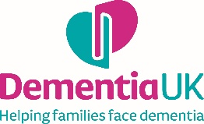
Social media copy to announce a partnership
Before sharing, please send a draft of your post to corporate.partnerships@dementiauk.org for final review.
We’re proud to announce Dementia UK as our new charity partner for the next [insert time-frame].
Dementia UK is the specialist dementia nursing charity that is there for the whole family. Its nurses, known as Admiral Nurses, provide expert, compassionate advice, support and guidance on Dementia UK’s free Helpline, in online appointments and face-to-face clinics, and in communities.
One in two people will be affected by dementia in their lifetime, so Dementia UK’s work has never been more important. This partnership, chosen by our colleagues, reflects our commitment to supporting families affected by dementia.
Together, we’ll raise funds and awareness to help expand Dementia UK’s vital services and ensure no one faces dementia alone.
Stay tuned for updates and ways you can get involved. 💙
[Insert link to fundraising page]

